**ASSISTED PRACTICE (RANDOM VARIABLES AND COUNTERS)**

Random Variables:

Step1: Open Jmeter -> Add Thread Group

Step2: Right click on Thread Group -> Add -> Config elements -> Random Variable

Step3: In Random Variable, Give the values as shown below:

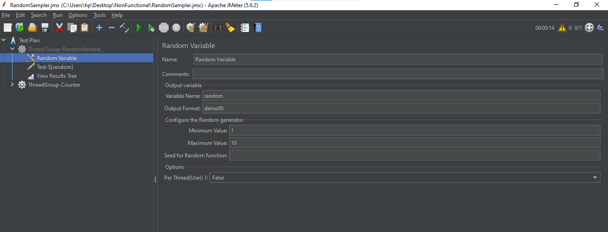

Step4: Right click on Thread Group -> Add -> Sampler -> Java Request

Step5: Give the name of Java Request as shown below:

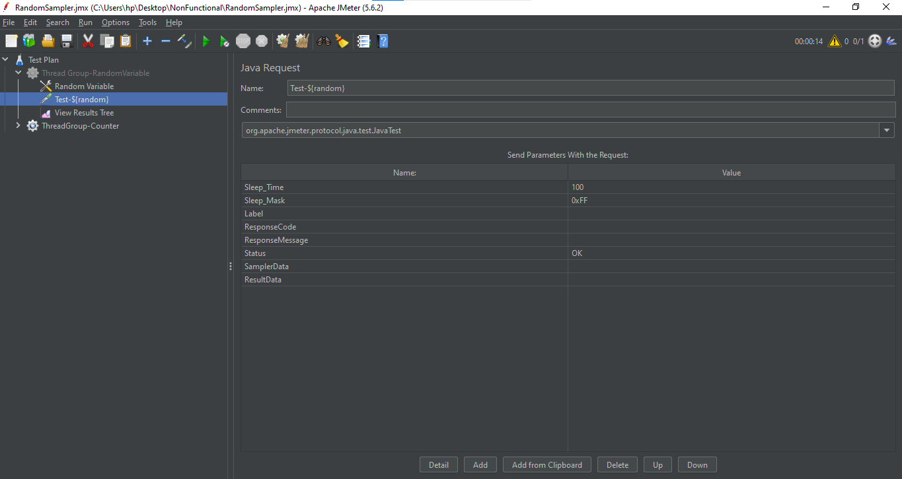

Step6: Right click on Thread Group -> Add -> Listener -> View Results Tree (to see the output)

Step7: Save it and execute

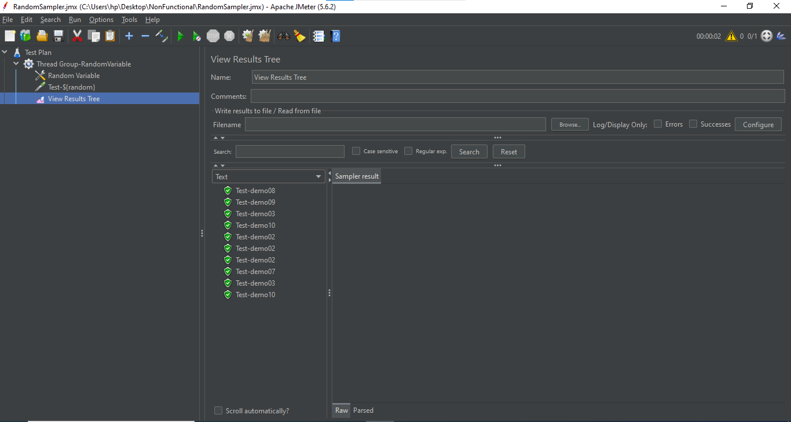

Counters:

Step1: Create another Thread Group for Counters

Step2: In Thread Group, Give the values as shown below:

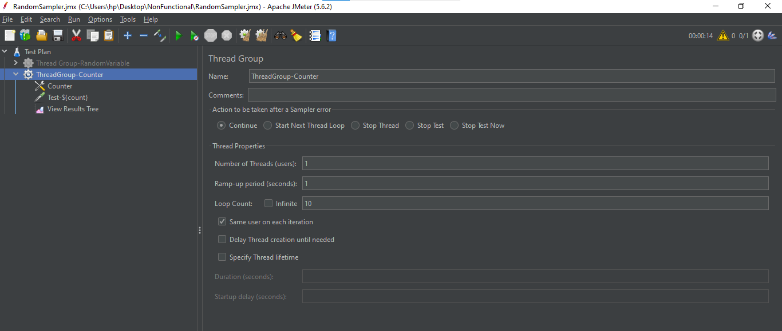

Step3: Right click on Thread Group -> Add -> Config elements -> Counter

Step4: In Counter, Give the following values:

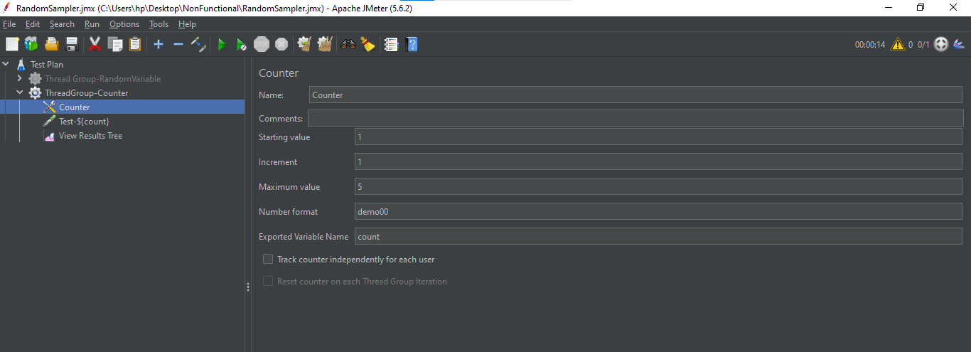

Step5: Right click on Thread Group -> Add -> Sampler -> Java Request

Step6: Give the name of Java Request as shown below:

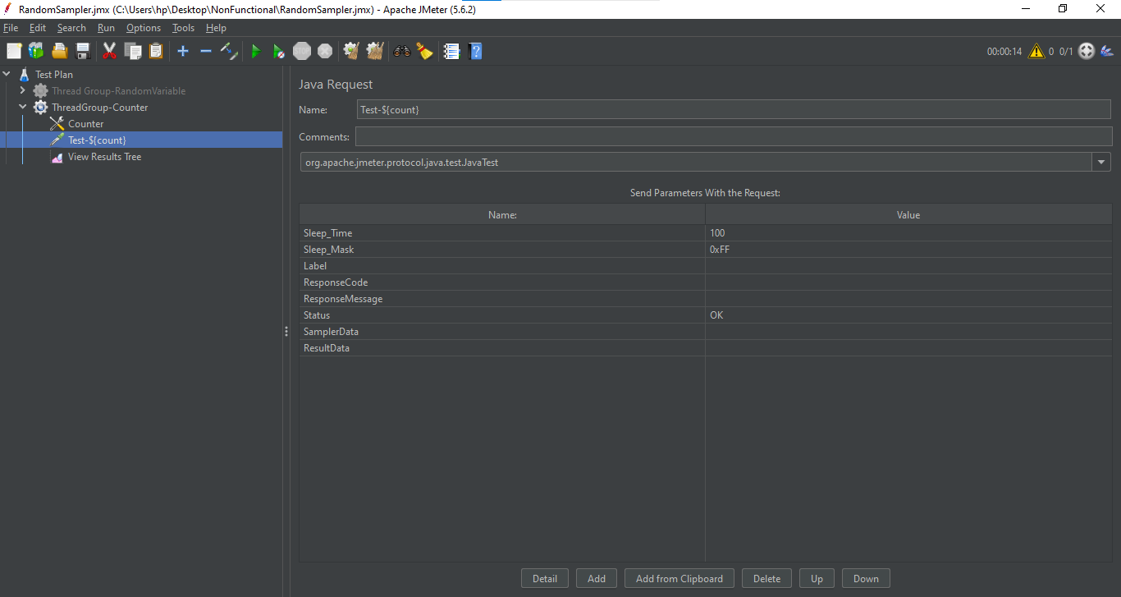

Step7: Right click on Thread Group -> Add -> Listener -> View Results Tree (to see the output)

Step8: Save it and execute

